

Internal Audit – Continuing Education

Process Understanding Document

Prepared by | Waseem alwahedy / Ahsan Niazi
Date | Jan 2023

Overview
XX
Department Vision
XX.
Department Mission
XX.

Strategic Goals and Objectives
XX.

Governance
XX.
Subcontracting
The Continuing Education Department has subcontracted to Emirates College for Advanced Education in terms of administrative work i.e. Learning Management System.

With the exception of trainers, who would be faculty / staff from KU, Emirates College for Advanced Education integrated Learning Management System (LMS) Masary is utilized by Continuing Education Department at KU which allows communication between Learners, Assessors, Internal Quality Assurers and System Administrators. Users can generate plans and reports, record learning progress and maintain ongoing achievements records.

Subcontracting for this software / utilizing service from Emirates College for Advanced Education allowed KU Continuing Education Department to move from manual registrations, publications, certifications etc. to an automated system.

Automation assisted in clients looking for trainings to visit KU’s website, find a suitable course and register online. Online registration was not available previously. Once registered, it would immediately go through the Masary software. A Massari account will be created, the client will make the payment for the course and will subsequently have access to course material and relevant training. After the course is completed, the attendees will get an electronic certification. This certification will remain in their account in Masary.
The Masary therefore is not only a learning management system but also a trainee information system, where their training certificates ara retained and can be accessed trainees for viewing and printing purposes at any time.

An Agreement / Contract is in place to utilize Masary Service by Emirates College for Advance Education.
Organisation Chart
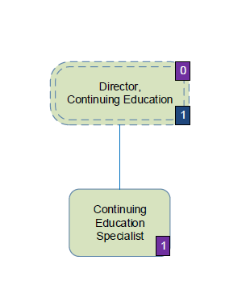
Budget vs Actuals
Payments (2022)
Revenue (2022)
Costing Basis for the courses / Trainings / Pricing Schedule
Registarant Statistics
Feedback / Surveys
Key Performance Indicators
Partnerships
Accreditatons / Certifications
Number of Courses Offered in 2022
Course / Training / Calendar
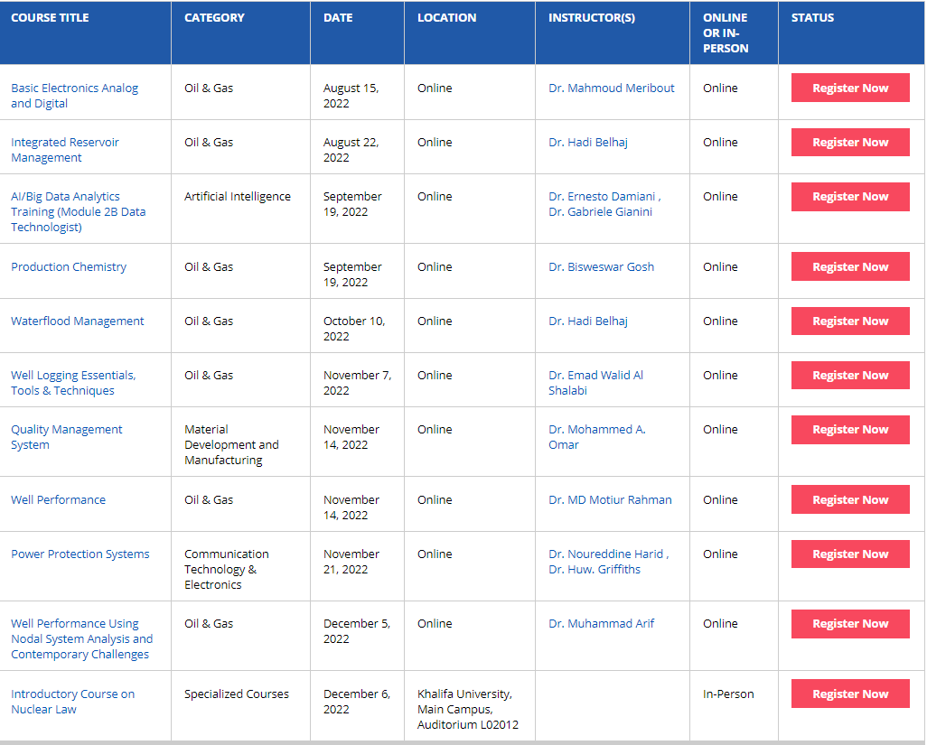
Reporting

